South Yorkshire Trading Standards Services

Motor Trade Business Partnership

About the Scheme

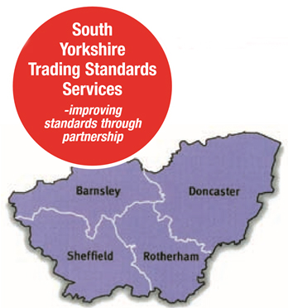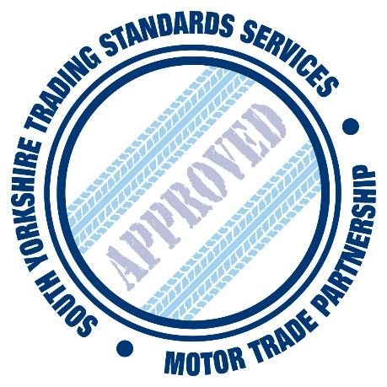

South Yorkshire Trading Standards Services

MOTOR TRADE BUSINESS PARTNERSHIP

About the Partnership
The South Yorkshire Trading Standards Motor Trade Business Partnership, (the Partnership), exists to promote good practice amongst its members in relation to Trading Standards legislation and consumer related matters.
All members of the scheme are expected to adhere to the Code of Professional Conduct, (the Code), and to the spirit of the Code to the fullest extent possible.
The Code will be reviewed from time to time to have regard for changes in Legislation and Good Business Practice.
Copies of the Code should be available at each member branch, and made available to prospective customers on request.

Consumer Guide
To promote the scheme a consumer guide will be produced.

The guide should be made readily available to all prospective customers as well as being handed to customers involved in the purchase of new and used vehicles.
The guide will contain details of:
- The purpose and aims of the partnership.
- The partnership logo.
- Consumer benefits.
- Details of the complaints procedure.
- Details of the nominated contact officers.
The Motor Trade Partnership requires its members to display consumer guide leaflets in a prominent position for potential customers, one of these leaflets should be included with the paperwork for each vehicle sale.

Benefits to Consumers
- Increased consumer confidence - traders have been audited / approved.
- Easy access to nominated senior representative at each dealership in the event of a problem.
- An effective customer complaints procedure, understood and implemented by all employees.
- Access to an Alternative Dispute Resolution Scheme run by South Yorkshire Trading Standards Services if problems cannot be resolved.
- Consumer Guide available at each dealership.

Benefits to Business
- Increased consumer confidence and reduced numbers of complaints .
- Training Seminars provided by Trading Standards to traders to increase understanding in major legal areas.
- Recognition of business standards and good practice.
- Publicity, advertising, marketing opportunity and use of the dedicated scheme logo.
- Information and legal advice from designated Trading Standards contacts.
- The Dedicated Web Site (http://www.motortradingstandards.co.uk/) providing a range of resources for consumers, information about the partnership and comprehensive membership details, including links to the member’s own web facilities.
- A consumer guide available through members, Trading Standards and other agencies.
- Certificate of Membership.
- Free assistance and advice on staff training where appropriate and the opportunity for members to arrange comprehensive training packages tailored to specific needs.
- Membership seminars, including legislative training and topical issues.
- Access to a free Alternative Dispute Resolution Scheme run by South Yorkshire Trading Standards Services if problems cannot be resolved.

Contact Details
For general information about the scheme, please contact:
Tracey Lane (Partnership Development Officer)
Tel: 01302 737324

Email: tracey.lane@doncaster.gov.uk

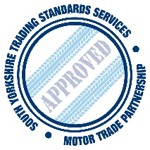
The Partnership Logo
The Scheme logo can be displayed on the dealer’s premises and on promotional literature to further publicise the scheme.

Alternative Dispute Resolution Scheme
When members are unable to satisfactorily resolve a customer’s complaint through their own in-house complaints procedure the consumer may ask for it to be referred to the ADR scheme.
The ADR scheme is run on member’s behalf by South Yorkshire Trading Standards Services to give it transparency and independence. It uses suitably qualified and experienced Trading Standards professionals to administer a two stage process at no extra cost to Partnership Members. The process is externally accredited by the Chartered Trading Standards Institute.

The first Stage is mediation and uses an experienced case officer to speak to both parties to try and find a practical solution that is acceptable to both parties.
If this is unsuccessful in the second stage an Adjudicator will be appointed to examine the written evidence of both parties before making a financial award if deemed appropriate. This is binding on the Trader.
The ADR Scheme is designed to be a quick, easy method of resolving difficult disputes eliminating the court process.

